**C Series**

Amco Veba has many years of experience in special applications requested in different markets present all over the world such as agriculture, defence, tire handling, car recovery, aerial operations.

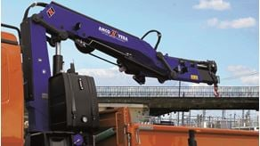

**909NGC**

Max. Lifting capacity (kg)

2390

Lifting Moment Class (tm)

9

Max. Extension reach (m)

8.75



**911NGC**

Max. Lifting capacity (kg)

2665

Lifting Moment Class (tm)

11

Max. Extension reach (m)

8.87



**914NGC**

Max. Lifting capacity (kg)

3210

Lifting Moment Class (tm)

13

Max. Extension reach (m)

9.15



**917NGC**

Max. Lifting capacity (kg)

4010

Lifting Moment Class (tm)

16

Max. Extension reach (m)

9.23



**921NGC**

Max. Lifting capacity (kg)

5280

Lifting Moment Class (tm)

19

Max. Extension reach (m)

11.08

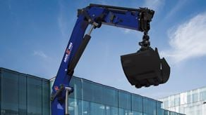

**924NGC**

Max. Lifting capacity (kg)

6090

Lifting Moment Class (tm)

21

Max. Extension reach (m)

11.25

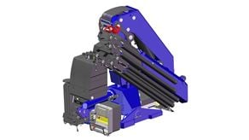

**941NGC**

Max. Lifting capacity (kg)

6090

Lifting Moment Class (tm)

21

Max. Extension reach (m)

11.25